

Darshan University

A Project Report on
“Loan Management System”
Under the subject
Software Engineering (2301CS405)
B. Tech, Semester – IV
Computer Science & Engineering Department

Submitted By
Student Name: Kalp Vipul Viradia | Enrollment No.: 23010101299
Academic Year
(2024-2025)
Internal Guide  Prof. R. B. Gondaliya  Darshan University | Dean-DIET  Dr. Gopi Sanghani  Darshan University

 | Computer Science & Engineering Department  Darshan University

DECLARATION

We hereby declare that the SRS, submitted along with the Software Engineering (2301CS405) for entitled “Loan Management System” submitted in partial fulfilment for the Semester-5 of Bachelor Technology (B. Tech) in Computer Science and Engineering (CSE) Department to Darshan University, Rajkot, is a record of the work carried out at Darshan University, Rajkot under the supervision of R. B. Gondaliya and that no part of any of report has been directly copied from any students’ reports, without providing due reference.

(Kalp Vipul Viradia)

Student’s Signature
Date: 01/03/2025

 | Computer Science & Engineering Department  Darshan University

CERTIFICATE

This is to certify that the SRS on “Loan Management System” has been satisfactorily prepared by Kalp Vipul Viradia (23010101299) under my guidance in the fulfillment of the course Software Engineering (2301CS405) work during the academic year 2024-2025.

Internal Guide  Prof. R. B. Gondaliya  Darshan University |  | Dean-DIET  Dr. Gopi Sanghani  Darshan University

Acknowledgement
I wish to express my sincere gratitude to my project guide Prof. R. B. Gondaliya and all the faculty members for helping me through my project by giving me the necessary suggestions and advices along with their valuable co- ordination in completing this work.
I also thank my parents, friends and all the members of the family for their precious support and encouragement which they had provided in completion of my work. In addition to that, I would also like to mention the Darshan University personals who gave me the permission to use and experience the valuable resources required for the project from the University premises.
Thus, in conclusion to the above said, I once again thank the faculties and members of Darshan University for their valuable support in completion of the project.

Thanking You
Kalp Vipul Viradia

ABSTRACT
The Loan Management System (LMS) is a digital solution designed to automate and streamline the entire loan process for financial institutions. This system simplifies loan application, approval, repayment, and reporting, reducing manual efforts and ensuring accuracy. It offers a user-friendly interface for both clients and loan officers, enabling clients to apply for loans securely and track their repayment schedules. Once a loan application is submitted, loan officers can review, approve, or reject it, with the system automatically updating the status. Clients can view their outstanding balances and make payments through integrated payment gateways.

Administrators can generate comprehensive reports on loan disbursements, repayments, and overdue loans, helping in effective resource management. The system’s secure login and data privacy features ensure that client information is protected. By reducing paperwork, minimizing human error, and improving operational efficiency, the LMS enhances both the loan management process and the customer experience, providing a seamless and efficient solution for loan handling.

Main purpose of this system is to reduce human efforts as much as possible.

Table of Contents
List of Figures I
List of Tables II
1 Introduction 1
1.1 Product perspective 1
1.2 Product features 1
1.2.1 There are three different users who will be using this product: 1
1.2.2 The features that are required for the Admin are: 1
1.2.3 The features that are required for the Loan officer are: 1
1.2.4 The features that are required for the Customer are: 1
1.3 Functional Requirement 2
1.3.1 Admin 2
1.3.2 Loan Officer 2
1.3.3 Customer 2
1.4 Non-Functional Requirement 3
1.4.1 Usability: 3
1.4.2 Accuracy: 3
1.4.3 Availability: 3
1.4.4 Maintainability: 3
2 Design and Implementation Constraints 4
2.1 Use case diagram 4
2.2 Activity diagram and Swimlane diagram 4
2.3 Sequence diagram 7
2.4 State diagram 9
2.5 Class diagram 9
2.6 Data flow diagram 11
2.6.1 Context diagram (level-0) 11
2.6.2 DFD Level-1 12
2.6.3 DFD Level-2 12
3 External interface requirement (Screens) 13
3.1 Screen-1: Registration Form 13
3.2 Screen-2: Loan Status 15
3.3 Screen-3: Update Customer Profiles 17
3.4 Screen – 4: Review Loan Applications 19
Screen – 5: Apply For Loan 21
4 Database design 23
4.1 List of Tables 23
5 Stories and Scenario 25
5.1 Story-1: Add New Loan Type in Loan Catalogue 25
5.1.1 Scenario# S1.1 25
5.1.2 Scenario# S1.2 25
5.2 Story-2: Generate Reports 26
5.2.1 Scenario# S2.1 26
5.2.2 Scenario# S2.2 26
5.3 Story-3: Repay Loan 27
5.3.1 Scenario# S3.1 27
5.3.2 Scenario# S3.2 27
6 Test Cases 28
7 References 34

List of Figures

Figure 2.1-1 Use case diagram for loan management system 4
Figure 2.2-1 Activity diagram for taking loan 5
Figure 2.3-1 Sequence diagram for taking loan 8
Figure 2.4-1 State diagram for loan 9
Figure 2.4-2 State diagram for payment 9
Figure 2.5-1 Class diagram for Library management system 10
Figure 2.6-1 Context diagram for Library management system 11
Figure 2.6-2 DFD level-1 for Library management system 12
Figure 2.6-3 DFD level-2 for Issue book 12
Figure 3.1-1 Screen-1: Registration Form 13
Figure 3.2-1 Screen-2: Loan Status 16
Figure 3.3-1 Screen-3: Update Customer Profiles 17
Figure 3.4-1 Screen-4: Review Loan Applications 19
Figure 3.5-1 Screen-5: Apply For Loan 21

List of Tables

Table 3.1-1 Screen element of Registration form 13
Table 3.2-1 Screen element of Loan Status 16
Table 3.3-1 Screen element of Update Customer Profiles 17
Table 3.4-1 Screen element of Review Loan Applications 19
Table 3.5-1 Screen element of Apply For Loan 22
Table 4.1-1 Table: Loan Product 23
Table 4.1-2 Table: Users 23
Table 4.1-3 Table: Loan Officer 23
Table 4.1-4 Table: Repayment 24
Table 4.1-5 Table: Statements 24

Introduction

Product perspective
The Loan Management System (LMS) is designed to streamline the processes involved in managing loans, from origination to closure. It serves as a comprehensive solution for financial institutions, providing robust functionality to automate and manage loan-related operations efficiently.

Product features

There are three different users who will be using this product:
- Admin: Oversees the entire system and has full control over its functionality.
- Loan Officer: Handle loan operations, customer interactions, and compliance.
- Customer: Individuals applying for loan and view their loans.

The features that are required for the Admin are:
- Oversee all loan operations and monitor system activities.
- Add, edit, or delete loan products, including their terms (interest rates, tenure, and eligibility criteria).
- Monitor system users (Loan Officers and Customers), including account creation, modification, and deactivation.
- Make and analyse detailed reports, including loan disbursement, overdue accounts, and revenue data.
- Configure system settings, including repayment penalties, grace periods, and automated notifications.
- Monitor compliance with regulatory requirements and generate audit reports.
- Handle system backups and data recovery processes.
- Assign roles and permissions for Loan Officers.
- Monitor the performance of Loan Officers through task and target tracking.

The features that are required for the Loan officer are:
- Review and process loan applications, including document verification and credit assessment.
- Approve or reject loans based on customer eligibility and internal guidelines.
- Track the status of loans, including disbursement and repayments.
- View detailed customer profiles, including their loan history, repayment behaviour, and credit scores.
- Send reminders and notifications to customers regarding due dates and overdue payments.
- Generate customer-specific reports, such as outstanding balances and repayment schedules.
- Respond to customer queries or requests for loan restructuring or early closure.
- Record and track interactions with customers for future reference.
- Monitor pending tasks and customer escalations assigned by the Admin.

The features that are required for the Customer are:
- View available loan products with details such as interest rates, tenure, and eligibility requirements.
- Apply for loans by submitting necessary documentation and filling out the application form.
- Track the status of loan applications and receive updates on approvals or rejections.
- Access their loan account to view repayment schedules, outstanding balances, and due dates.
- Make loan repayments through integrated payment gateways or other channels.
- Request changes to loan terms, such as tenure extension or restructuring.
- Access notifications and reminders for upcoming repayments or overdue amounts.
- Update personal details such as address, contact information, or bank account details.

Functional Requirement

Admin
- Add Loan Product: Add new loan products with details such as interest rate, tenure, eligibility criteria, and terms and conditions to the system.
- Update Loan Product: Modify existing loan products if there are changes in terms, rates, or eligibility criteria.
- Delete Loan Product: Remove discontinued or incorrect loan products from the system.
- Store Users: Maintain a database of all system users, including Loan Officers and Customers, with details like names, IDs, and permissions.
- Set User Permissions: Assign specific roles and access levels to Loan Officers.
- Generate Reports: Create detailed reports on loans, overdue accounts, revenue, and regulatory compliance.
- Backup and Recovery: Take system backups and ensure data recovery in case of failures.
- Audit Logs: Track all system activities and modifications for compliance and accountability.
- Monitor Loan Officer Performance: Track tasks and performance metrics of Loan Officers.

Loan Officer
- Authenticate: Loan Officers must log in with valid credentials to access the system.
- Review Loan Applications: Assess customer loan applications, verify submitted documents, and evaluate eligibility criteria.
- Approve/Reject Loans: Decide the approval or rejection of loan applications based on customer creditworthiness and institutional guidelines.
- Manage Customer Profiles: Access and update customer records, including personal details and loan histories.
- Track Loans: View the lifecycle of loans, including application, disbursement, and repayment.
- Send Notifications: Notify customers about due dates, overdue payments, or changes in loan terms.
- Generate Customer Reports: Create detailed reports specific to individual customers, such as repayment schedules and outstanding balances.
- Request Loan Restructuring: Process customer requests for changes in loan terms, such as tenure extension or repayment restructuring.
- Handle Customer Queries: Respond to customer inquiries about loans or system-related issues.

Customer
- Authenticate: Customers must log in using valid credentials to access their accounts.
- Apply for Loan: Submit loan applications with all required information and supporting documents.
- Track Loan Application: View the status of their loan application, including updates on approvals or rejections.
- View Loan Details: Access detailed information about their loans, including repayment schedules, interest rates, and outstanding balances.
- Make Repayments: Pay EMIs or clear overdue payments through integrated payment gateways.
- Request Loan Changes: Submit requests for loan restructuring, early closure, or increases in loan amounts.
- Search Loan Products: Browse available loan products and calculate EMIs using a loan calculator.
- Access Notifications: View alerts for upcoming due dates, payment confirmations, and system updates.
- Update Personal Details: Update account information, including address, contact details, or linked bank accounts.
- Download Statements: Retrieve loan account statements and payment receipts for record-keeping.

Non-Functional Requirement

Usability:
- The UI should be simple enough for everyone to understand and get the relevant information without any special training. Different languages can be provided based on the requirements.

Accuracy:
- The data stored about the books and the fines calculated should be correct, consistent, and reliable.

Availability:
- The System should be available for the duration when the library operates and must be recovered within an hour or less if it fails. The system should respond to the requests within two seconds or less.

Maintainability:
- The software should be easily maintainable and adding new features and making changes to the software must be as simple as possible. In addition to this, the software must also be portable.

Design and Implementation Constraints

Use case diagram

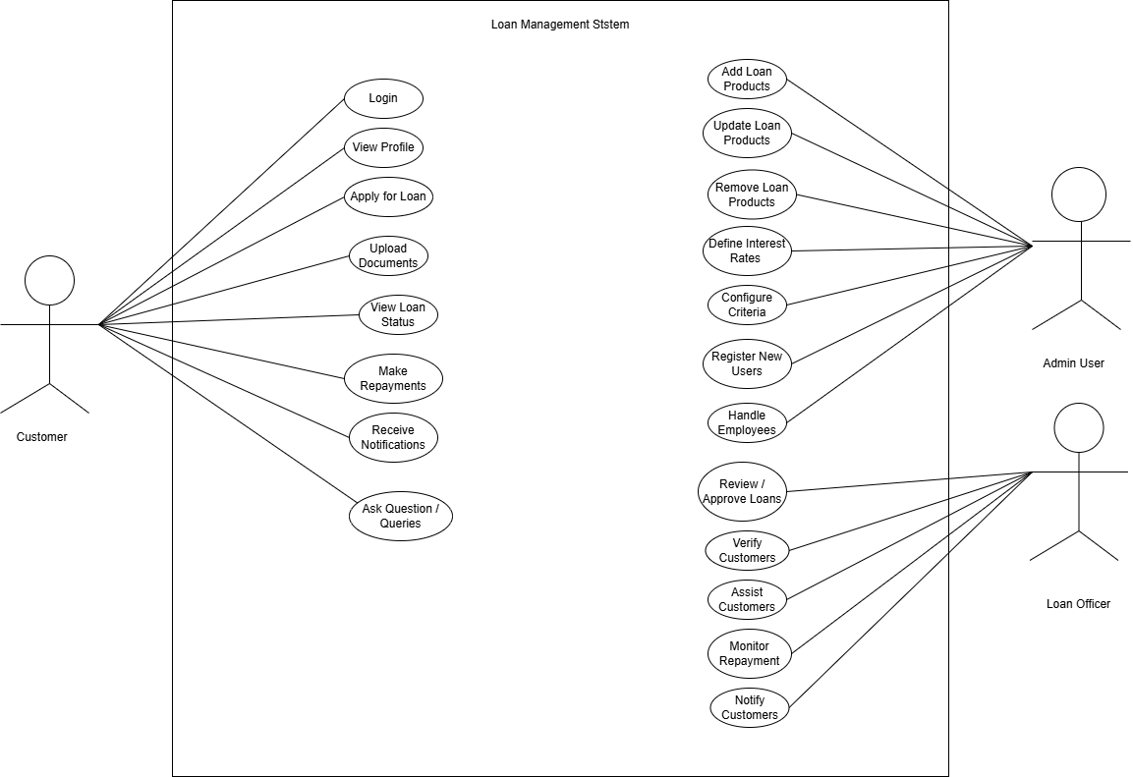
Figure 2.1-1 Use case diagram for loan management system

Activity diagram and Swimlane diagram

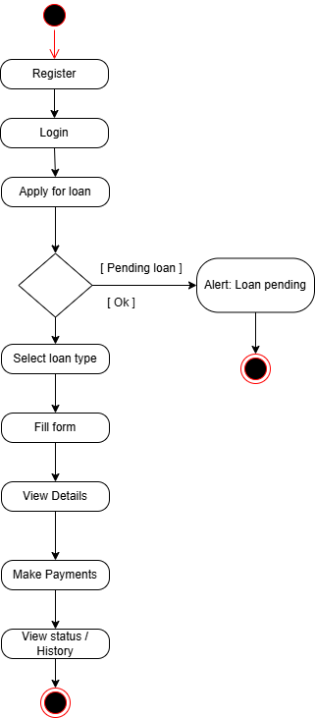
Figure 2.2-1 Activity diagram for taking loan

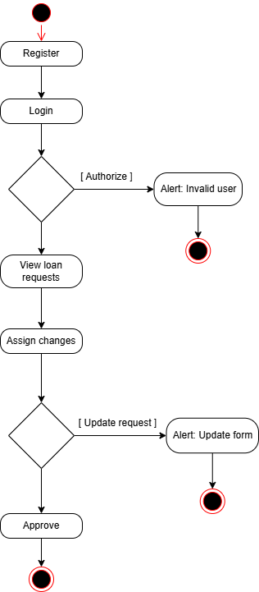
Figure 2.2-2 Activity diagram for approving loan

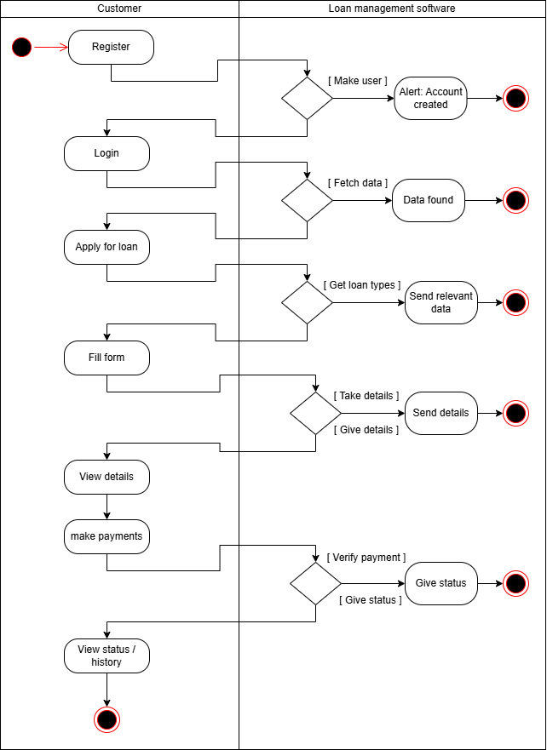
Figure 2.2-3 Swimlane diagram for taking loan

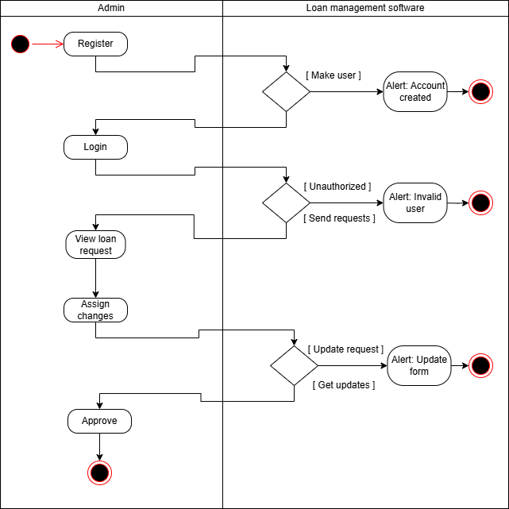
Figure 2.2-4 Swimlane diagram for approving loan

Sequence diagram

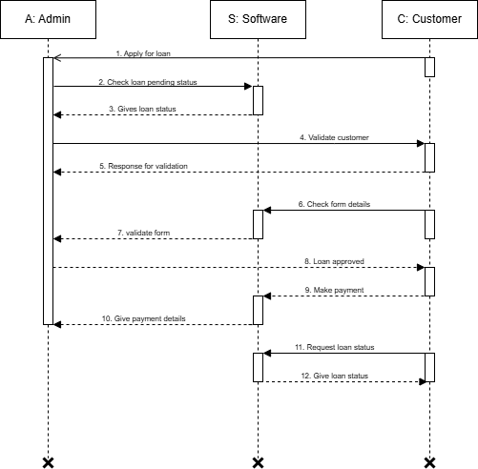
Figure 2.3-1 Sequence diagram for taking loan

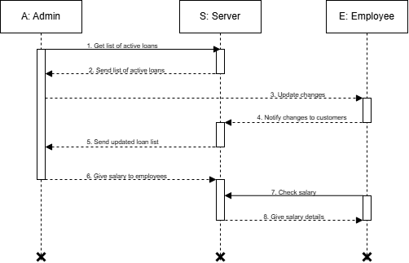
Figure 2.3-2 Sequence diagram for admin user

State diagram

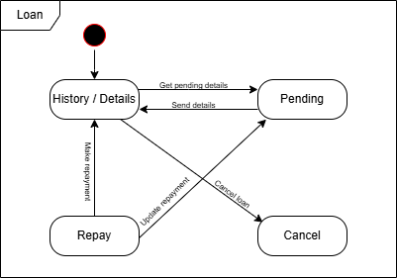
Figure 2.4-1 State diagram for loan
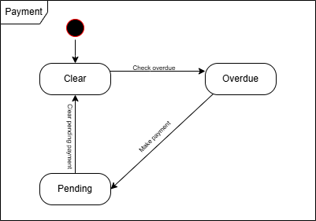
Figure 2.4-2 State diagram for payment

Class diagram

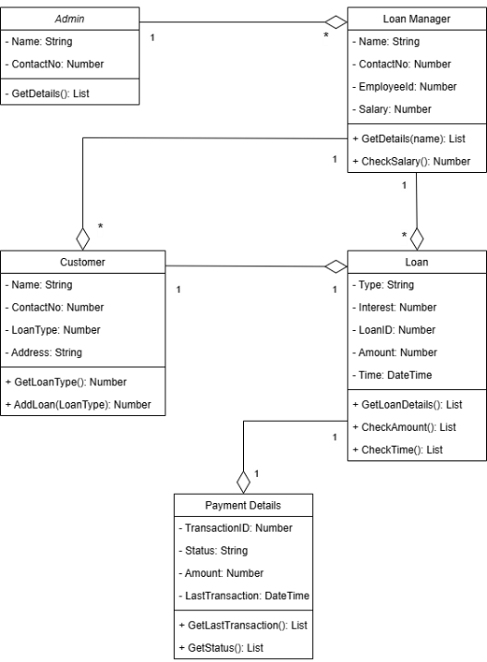
Figure 2.5-1 Class diagram for Library management system

Data flow diagram

Context diagram (level-0)
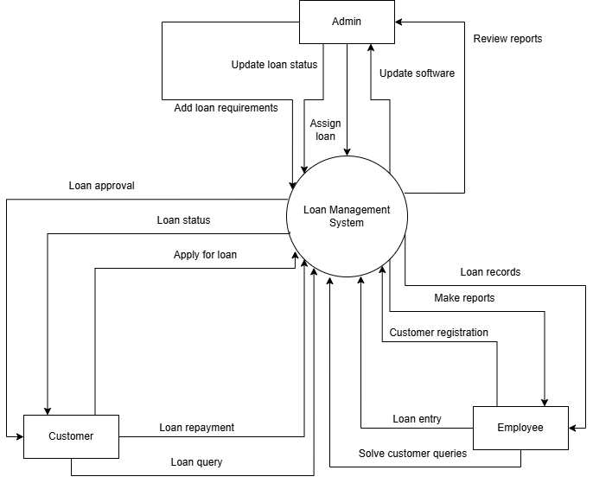
Figure 2.6-1 Context diagram for Library management system

DFD Level-1
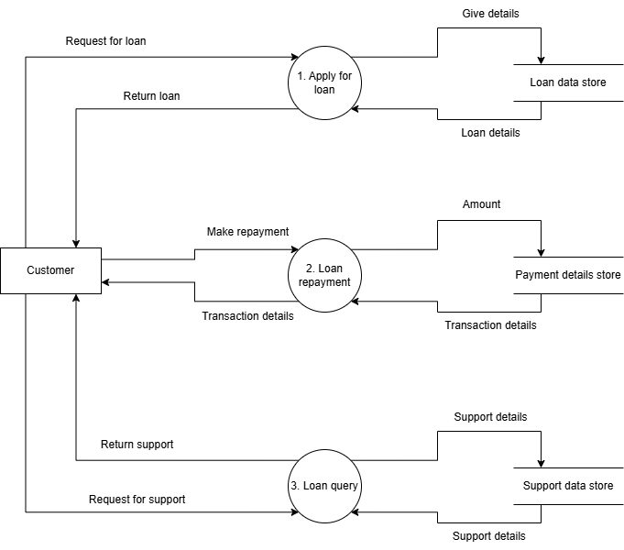
Figure 2.6-2 DFD level-1 for Library management system

DFD Level-2
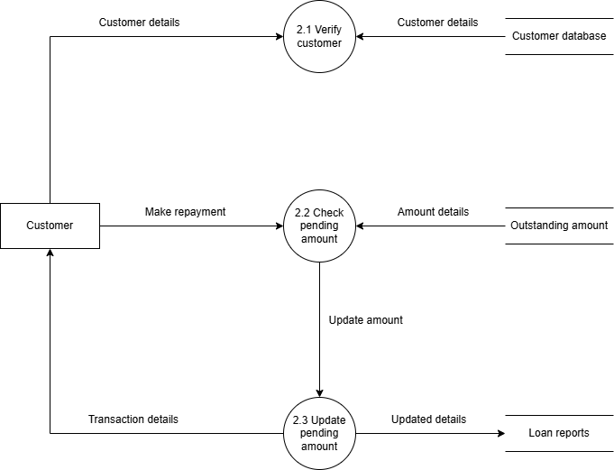
Figure 2.6-3 DFD level-2 for Issue book

External interface requirement (Screens)

Screen-1: Registration Form
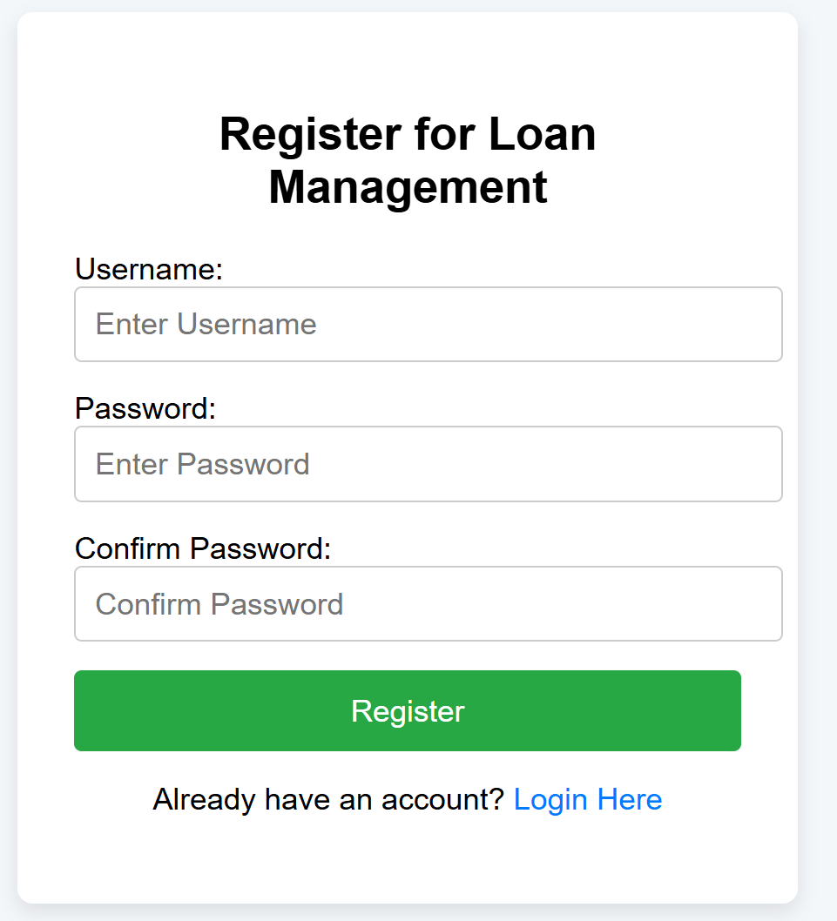
Figure 3.1-1 Screen-1: Registration Form

Purpose: This form will allow the target end-users to register in the system. To register , the following information will be encoded in the system.

Table 3.1-1 Screen element of Registration form
Sr. | Screen Element | Input Type | O/M | 1/N | Description
1 | Username | Textbox | M | 1 | Username field should be editable and accept the Username.
2 | Email | Textbox | M | 1 | Email field should be editable and accept the email with proper format.
3 | Password | Password | M | 1 | Password field should be editable and accept the password and display as star or dot.
4 | Confirm password | Password | M | 1 | Confirm Password field should be editable and accept the password and display as star or dot.
6 | Register | Button | ------ | ------ | Register is a button for store the entered data into database.
7 | Login Here | Button | ------ | ------ | Login Here is a button to change the screen from register to login

Screen-2: Loan Status
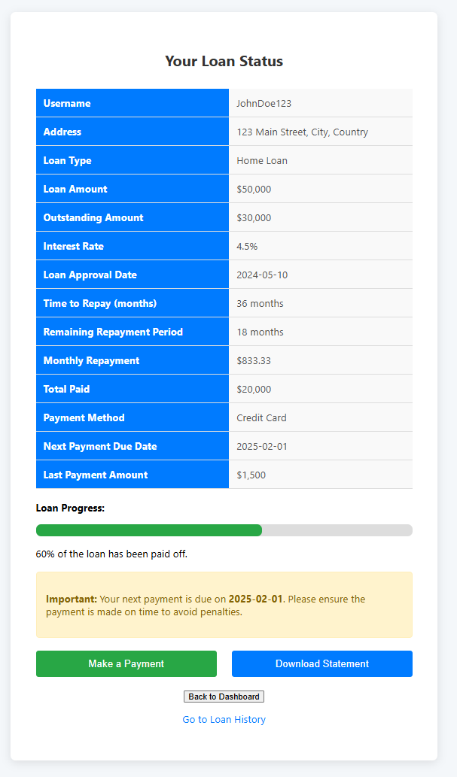
Figure 3.2-1 Screen-2: Loan Status
Purpose: This screen allows users to view the current status of their loan, including key details such as the loan amount, outstanding balance, monthly repayments, and next payment due date. Users can also track their loan progress via a visual progress bar and receive important notifications regarding their repayment schedule. Additionally, this screen provides options to make a payment, download a loan statement, or navigate back to the dashboard.
Table 3.2-1 Screen element of Loan Status
Sr. | Screen Element | Input Type | O/M | 1/N | Description
1 | Username | Textbox | M | 1 | Displays the username of the user.
2 | Address | Textbox | M | 1 | Displays the address of the user.
3 | Loan Type | Text | M | 1 | Displays the type of loan.
4 | Loan Amount | Text | M | 1 | Displays the total loan amount granted to the user.
5 | Outstanding Amount | Text | M | 1 | Displays the remaining loan balance that is yet to be paid.
6 | Interest Rate | Text | M | 1 | Displays the interest rate applied to the loan.
7 | Loan Approval Date | Text | M | 1 | Displays the date on which the loan was approved.
8 | Time to Repay | Text | M | 1 | Displays the total repayment time in months.
9 | Remaining Repayment Period | Text | M | 1 | Displays the remaining repayment period in months.
10 | Monthly Repayment | Text | M | 1 | Displays the amount that the user needs to repay monthly.
11 | Total Paid | Text | M | 1 | Displays the total amount the user has already paid toward the loan.
12 | Payment Method | Text | M | 1 | Displays the payment method used by the user.
13 | Next Payment Due Date | Date | M | 1 | Displays the next due date for the loan repayment.
14 | Last Payment Amount | Text | M | 1 | Displays the amount of the last payment made by the user.
15 | Loan Progress Bar | Progress Bar | M | 1 | Displays the loan repayment progress visually.
16 | Notifications | Text | O | 1 | Displays important notifications related to the loan status.
17 | Make a Payment | Button | ------ | ------ | Button to redirect the user to a payment gateway.
18 | Download Statement | Button | ------ | ------ | Button to allow the user to download the loan statement.
19 | Back to Dashboard | Button | ------ | ------ | Button to return the user to the dashboard or previous page.
20 | Go to Loan History | Link | ------ | ------ | Link to navigate to the loan history page.

Screen-3: Update Customer Profiles
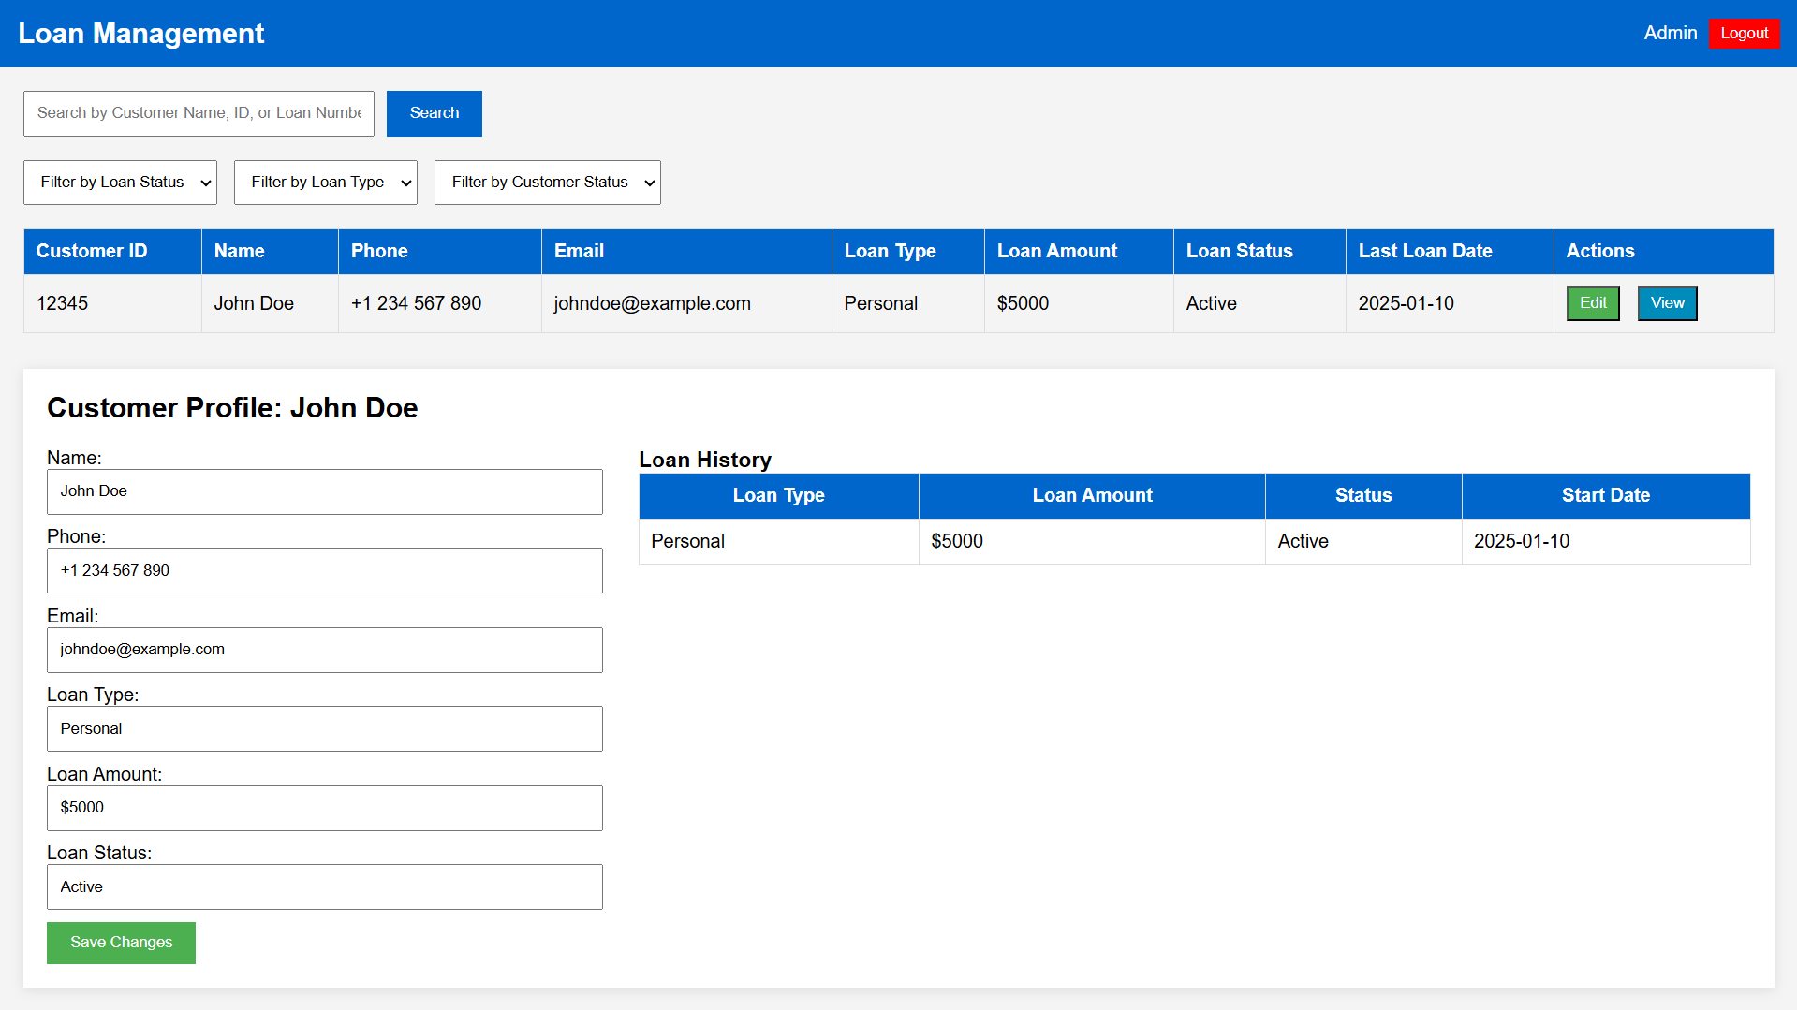
Figure 3.3-1 Screen-3: Update Customer Profiles

Purpose: This screen allows admins to search, filter, and view customer loan information. Admins can edit customer profiles and access loan histories for efficient oversight.
Table 3.3-1 Screen element of Update Customer Profiles
Sr. | Screen Element | Input Type | O/M | 1/N | Description
1 | Customer ID | Textbox | M | 1 | Displays the unique customer ID for reference.
2 | Customer Name | Textbox | M | 1 | Displays and allows editing of the customer’s name.
3 | Customer Phone | Textbox | M | 1 | Displays and allows editing of the customer's phone number.
4 | Customer Email | Textbox | M | 1 | Displays and allows editing of the customer's email address.
5 | Loan Type | Textbox | M | 1 | Displays the loan type (Personal, Auto, Home) for the customer.
6 | Loan Amount | Number Input | M | 1 | Displays and allows editing of the loan amount for the customer.
7 | Loan Status | Textbox | M | 1 | Displays the current loan status (Active, Closed, Pending).
8 | Last Loan Date | Date Input | M | 1 | Displays the last loan date (when the loan was granted).
9 | Edit Button | Button | ---- | 1 | Button to edit the customer’s loan information.
10 | View Button | Button | ---- | 1 | Button to view the detailed loan and customer information.
11 | Customer Profile - Name | Textbox | M | 1 | Editable text field for the customer’s name in the profile section.
12 | Customer Profile - Phone | Textbox | M | 1 | Editable text field for the customer’s phone number in the profile section.
13 | Customer Profile - Email | Textbox | M | 1 | Editable text field for the customer’s email address in the profile section.
14 | Loan Type (Profile Section) | Textbox | M | 1 | Editable text field for the loan type (e.g., Personal, Auto) in the customer profile section.
15 | Loan Amount (Profile Section) | Textbox | M | 1 | Editable text field for the loan amount in the customer profile section.
16 | Loan Status (Profile Section) | Textbox | M | 1 | Editable text field for the loan status (e.g., Active, Pending) in the customer profile section.
17 | Save Changes Button | Button | ---- | 1 | Button to save the edited customer details and loan information.
18 | Loan History Table | Table | M | 1 | Displays a table with loan history information for the customer, including loan type, amount, and status.
19 | Loan History - Loan Type | Textbox (Read-Only) | ---- | N | Displays the type of loan for each entry in the loan history.
20 | Loan History - Loan Amount | Textbox (Read-Only) | ---- | N | Displays the amount of the loan in the loan history table.
21 | Loan History - Loan Status | Textbox (Read-Only) | ---- | N | Displays the loan status for each loan entry in the loan history table.
22 | Loan History - Start Date | Date Input (Read-Only) | ---- | N | Displays the start date of each loan in the loan history table.

Screen – 4: Review Loan Applications
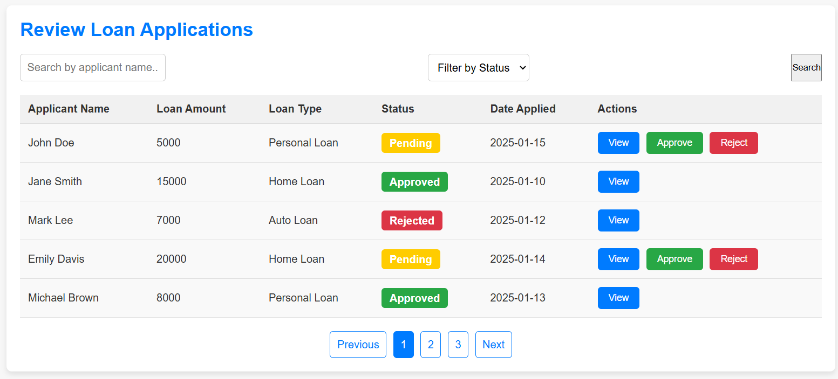
Figure 3.4-1 Screen-4: Review Loan Applications
Purpose: This screen allows users to review loan applications, search and filter by applicant name or loan status, and take action on pending applications. Admins can approve or reject loans, view application details, and navigate through paginated results to efficiently manage loan review tasks.

Table 3.4-1 Screen element of Review Loan Applications
Sr. | Screen Element | Input Type | O/M | 1/N | Description
1 | Search by Applicant Name | Textbox | O | 1 | Input field for searching by applicant name.
2 | Filter by Status | Dropdown (Select) | O | 1 | Dropdown to filter loan applications by status (Pending, Approved, Rejected).
3 | Search Button | Button | ---- | 1 | Button to trigger the search functionality based on the entered name and selected status.
4 | Applicant Name (Table Column) | Static Text | ---- | N | Displays the name of the loan applicant in the table.
5 | Loan Amount (Table Column) | Static Text | ---- | N | Displays the loan amount in the table.
6 | Loan Type (Table Column) | Static Text | ---- | N | Displays the type of loan in the table.
7 | Loan Status (Table Column) | Static Text (Status Badge) | ---- | N | Displays the loan status with a badge (Pending, Approved, Rejected).
8 | Date Applied (Table Column) | Static Text | ---- | N | Displays the date when the loan was applied.
9 | View Loan Button | Button | ---- | N | Button to view the details of a specific loan application.
10 | Approve Loan Button | Button | O | N | Button to approve a loan application (only visible for pending applications).
11 | Reject Loan Button | Button | O | N | Button to reject a loan application (only visible for pending applications).
12 | Previous Pagination Button | Button/Link | ---- | 1 | Button/link to navigate to the previous page of loan applications.
13 | Page Number (Pagination) | Button/Link | ---- | N | Buttons for pagination to move between pages of loan applications.
14 | Next Pagination Button | Button/Link | ---- | 1 | Button/link to navigate to the next page of loan applications.

Screen – 5: Apply For Loan
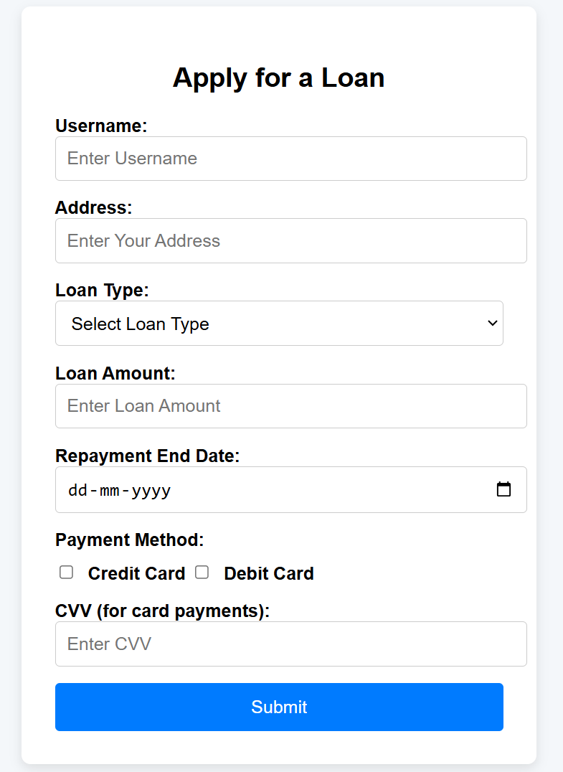
Figure 3.4-2 Screen-5: Apply For Loan
Purpose: This page allows users to apply for a loan by providing personal details, selecting a loan type, specifying the loan amount, and choosing a repayment date. Users can also select a payment method and provide CVV details for card payments. Upon submission, the application calculates the loan repayment period and alerts the user.
Table 3.4-2 Screen element of Apply For Loan
Sr. | Screen Element | Input Type | O/M | 1/N | Description
1 | Username | Textbox | M | 1 | Username field should be editable and accept the Username.
2 | Address | Textbox | M | 1 | Address field should be editable and accept the Address.
3 | Loan Type | Dropdown | M | 1 | Loan Type field should be editable and allow the user to select from options.
4 | Loan Amount | Number Input | M | 1 | Loan Amount field should be editable and accept numeric values for the loan amount.
5 | Repayment End Date | Checkbox Group | M | 1 | Repayment End Date field should be editable and allow the user to select a date.
6 | Payment Method | Checkbox Group | O | 1 | A group of checkboxes to select payment methods.
7 | CVV | Password | M | 1 | CVV field should be editable and accept the 3 or 4 digit CVV.
8 | Submit | Button | ------ | ------ | Submit button to send the loan application data to the backend.

Database design

List of Tables
- Loan Product
- Users
- Loan Officer
- Repayment
- Statements

Table 4.1-1 Table: Loan Product
Column | Data Type | Null | Keys & Constrains | Default Value & Description
LoanID | Int | NN | PK (Auto Increment)
LoanName | varchar(100) | NN
InterestRate | Decimal(8,2) | NN
EligibilityCriteria | Varchar(100) | NN
OfficerID | Int | NN | FK | Reference to Loan Officer

Table 4.1-2 Table: Users
Column | Data Type | Null | Keys & Constrains | Default Value & Description
UserID | Int | NN | PK (Auto Increment)
UserName | varchar(100) | NN
Contact | Int | NN
Address | Varchar(100) | NN
PendingLoan | Int | AN | FK | Reference to Loan Product
Permissions | Varchar(100) | AN

Table 4.1-3 Table: Loan Officer
Column | Data Type | Null | Keys & Constrains | Default Value & Description
EmpID | Int | NN | PK (Auto Increment)
EmpName | varchar(100) | NN
DepartmentID | Int | NN | FK | Reference to Loan Product
DepartmentName | Varchar(100) | NN
Salary | Int | NN

Table 4.1-4 Table: Repayment
Column | Data Type | Null | Keys & Constrains | Default Value & Description
TransactionID | Int | NN | PK (Auto Increment)
UserID | Int | NN | FK | Reference to Users
LoanID | Int | NN | FK | Reference to Loan Product
Overdue | Int | NN

Table 4.1-5 Table: Statements
Column | Data Type | Null | Keys & Constrains | Default Value & Description
StatementID | Int | NN | PK (Auto Increment)
UserID | Int | NN | FK | Reference to Users
TrancID | Int | NN | FK | Reference to Repayment
StatementDetails | Varchar(100) | NN

Stories and Scenario

Story-1: Add New Loan Type in Loan Catalogue

Story # S1 | : | As a Admin,  I want to add a new loan type in loan catalogue.  So that everyone can easily find and apply for it.
Priority | : | High
Estimate | : | XL
Reason | : | The addition of a new loan type to the loan catalogue is crucial for ensuring that the loan’s collection is up-to-date and accessible to everyone.

Scenario# S1.1
Scenario# S1.1 | : | Adding a New Loan Type with Valid Information
Prerequisite | : | Admin is logged in to the Loan management system.
Acceptance Criteria | : | Given: The Admin is navigated to the loan catalogue page. Valid loan information, including title, interest rates, tenure, and other relevant details is added.  When:  The admin selects the "Add New Loan Type" option  And The admin enters valid Loan details  The admin clicks the "Save" button to add the loan type to the catalogue.  Then the system successfully adds the loan type to the catalogue and the admin receives a confirmation message with the loan’s identification number.

Scenario# S1.2
Scenario# S1.2 | : | Adding a New Loan Type with Invalid Information.
Prerequisite | : | The admin is logged into the loan management system.
Acceptance Criteria | : | Given: The admin is on the loan catalogue management page  When: The admin selects the "Add New Loan Type" option and the admin enters an incomplete or incorrect loan details and admin clicks the "Save" button to add the loan type to the catalogue.  Then the system displays error messages for the incorrect or missing information and the loan type is not added to the catalogue.

Story-2: Generate Reports
Story # S2 | : | As a Loan officer,  I want to generate reports for active loans of users.  So that I can review the loans of users and suggest changes.
Priority | : | High
Estimate | : | M
Reason | : | Generating reports is crucial for monitoring loan performance and assisting users with better financial planning.

Scenario# S2.1
Scenario# S2.1 | : | Generate Active Loan Report
Prerequisite | : | Loan officer is logged into the system.
Acceptance Criteria | : | Given: The loan officer navigates to the "Reports" section.  When: The officer selects the "Active Loans Report" option and specifies a date range.  Then The system generates a report displaying all active loans with details such as customer name, loan amount, and due dates.

Scenario# S2.2
Scenario# S2.2 | : | Filter Reports by Loan Type
Prerequisite | : | Loan officer is logged into the system.
Acceptance Criteria | : | Given: The loan officer accesses the "Reports" section.  When: The officer selects "Filter by Loan Type" and chooses a loan category.  Then: The system generates a report displaying only loans of the selected type, allowing detailed analysis.

Story-3: Repay Loan
Story # S3 | : | As a customer,  I want to repay my loan through the system,  So that I can clear my dues conveniently and avoid penalties.
Priority | : | High
Estimate | : | M
Reason | : | A streamlined repayment process enhances customer experience and ensures timely loan settlements.

Scenario# S3.1
Scenario# S3.1 | : | Successful Loan Repayment
Prerequisite | : | Customer is logged into the Loan Management System and has an active loan.
Acceptance Criteria | : | Given: The customer navigates to the "Repay Loan" section.  When: The customer selects a loan, enters the repayment amount, and confirms the transaction.  Then The system processes the payment, updates the outstanding loan balance, and sends a confirmation message.

Scenario# S3.2
Scenario# S3.2 | : | Attempting Repayment with Insufficient Funds
Prerequisite | : | Customer is logged into the system and attempts to make a loan repayment.
Acceptance Criteria | : | Given: The customer selects a loan and enters the repayment amount.  When: The system detects that the account has insufficient funds.  Then: The system displays an error message and prevents the transaction from being processed.

Test Cases
Project Name: | LMS | Test Designed by: | Kalp V. Viradia
Module Name: | Login | Test Designed date: | 19-02-2025
Release Version: | 1.0 | Test Executed by: | R. B. Gondaliya
 |  | Test Execution date: | 19-02-2025
Pre-condition: Web application should be accessible
Test Case ID | Test Title | Test Type | Description | Test Case ID
TC_001 | Login to Loan Management System with valid credentials | Functional | Login to Loan Management System web application through valid credentials | TC_001
TC_002 | Login to web application with invalid credential | Functional | Login to Loan Management System web application through invalid credentials | TC_002

Test Case Title | Login to Loan Management System with valid credentials
Test Type | Functional
Test Priority | High
Pre-condition | Web application should be accessible. The user must have valid credentials.

Test Step | Test Case Description | Expected Result | Actual Result | Status | Comment | Data | BUG ID
1 | Access Web application URL | The site launched properly | Site launched successfully | Pass |  | https://accounts.google.com/ServiceLogin
2 | Enter valid Username in username field | Username field should be editable and accept the Username | Username input accepted | Pass |  | Username:  Rbgondaliya@gmail.com
3 | Enter valid Password in Password field | Password field should be editable and accept the password and display as star or dot | Password input displayed in dots and accepted | pass |  | Password:  rbgondaliya
4 | Enter valid captcha code in captcha field | Captcha field should editable and accept captcha and captcha is case sensitive | Captcha input accepted | Pass | Step required when human action validation perform | get captcha from image which is near by captcha field
5 | Click on login button | User should login into site and navigated to dashboard | User navigated to dashboard and username displayed on top of the right side. | pass

Test Case Title | Login to web application with invalid credentials
Test Type | Functional
Test Priority | Medium
Pre-condition | Web application should be accessible.

Test Step | Test Case Description | Expected Result | Actual Result | Status | Comment | Data | Bug ID
1 | Verify login with invalid username and invalid password | An error message should appear indicating wrong username or password | Error message displayed as "Wrong username or password" | Pass |  | Invalid Username: testuser@xyz.com, Invalid Password: testpassword
2 | Verify login with valid username and invalid password | An error message should appear indicating incorrect password | Error message displayed as "Incorrect password" | Pass |  | Username: rbgondaliya@gmail.com, Invalid Password: wrongpassword
3 | Verify login with invalid username and valid password | An error message should appear indicating "Username not found" | Error message displayed as "Username not found" | Pass |  | Invalid Username: testuser@xyz.com, Valid Password: rbgondaliya

Project Name: | LMS | Test Designed by: | Kalp V. Viradia
Module Name: | Loan Repayment Process | Test Designed date: | 19-02-2025
Release Version: | 1.0 | Test Executed by: | R. B. Gondaliya
 |  | Test Execution date: | 19-02-2025
Pre-condition: Web application should be accessible
Test Case ID | Test Title | Test Type | Description | Test Case ID
TC_001 | Loan Repayment Process | Functional | Test the loan repayment functionality to ensure the user can repay the loan successfully | TC_001
TC_002 | Loan Repayment with Invalid Amount | Functional | Ensure that the system validates repayment amounts that are invalid | TC_002

Test Case Title | Loan Repayment Process
Test Type | Functional
Test Priority | High
Pre-condition | Test the loan repayment functionality to ensure the user can repay the loan successfully

Test Step | Test Case Description | Expected Result | Actual Result | Status | Comment | Data | BUG ID
1 | Navigate to the Loan Repayment section from the dashboard | Loan Repayment section should open successfully | Loan Repayment section opened successfully | Pass
2 | View outstanding loan balance | The outstanding loan balance should be displayed | Outstanding balance of $5000 shown | Pass
3 | Enter repayment amount in the payment field | The user should be able to enter the repayment amount | Repayment amount of $1000 entered successfully | Pass | Payment field is editable | Amount: $1000
4 | Select payment method (e.g., Credit Card, Bank Transfer) | The user should be able to select a payment method from the dropdown | Payment method selected as Credit Card | Pass | Payment method dropdown functioning correctly | Credit Card
5 | Click on the "Repay Loan" button | Loan repayment should be processed successfully, and a confirmation message should appear | Loan repayment of $1000 processed successfully with confirmation message | Pass | Confirmation message: "Your loan repayment of $1000 has been successfully processed."
6 | Verify the updated loan balance | The loan balance should reflect the repayment amount and update accordingly | New balance displayed as $4000 | Pass | Balance updated successfully after repayment
7 | Verify email/SMS notification | User should receive a confirmation email or SMS regarding the loan repayment | Confirmation email received | Pass | Email received at rbgondaliya@gmail.com

Test Case Title | Login to web application with invalid credentials
Test Type | Functional
Test Priority | Medium
Pre-condition | Web application should be accessible. The user must be logged in and have an active loan with outstanding payments.

Test Step | Test Case Description | Expected Result | Actual Result | Status | Comment | Data | BUG ID
1 | Navigate to the Loan Repayment section from the dashboard | Loan Repayment section should open successfully | Loan Repayment section opened successfully | Pass
2 | View outstanding loan balance | The outstanding loan balance should be displayed | Outstanding balance of $5000 shown | Pass
3 | Enter an invalid repayment amount (e.g., negative or zero) | The system should reject the invalid amount and display an error message | Error message displayed: "Repayment amount must be a positive value" | Pass | Validation working as expected | Amount: -$100 or $0
4 | Attempt to proceed with invalid repayment amount | The system should not allow proceeding with the invalid repayment | Button to proceed remains disabled or hidden | Pass
5 | Enter a valid repayment amount (e.g., $1000) | The repayment amount should be accepted | Valid repayment amount of $1000 entered | Pass |  | Amount: $1000
6 | Proceed with the loan repayment | The loan repayment should be processed successfully | Loan repayment processed and confirmation displayed | Pass | Confirmation message: "Your loan repayment of $1000 has been successfully processed."
7 | Verify updated loan balance | The loan balance should reflect the repayment amount and update accordingly | New balance displayed as $4000 | Pass
8 | Verify email/SMS notification | User should receive a confirmation email or SMS regarding the loan repayment | Confirmation email received | Pass | Email received at rbgondaliya@gmail.com

References
- http://www.w3schools.com/html/html_intro.asp
- https://www.w3schools.com/php/default.asp
- https://www.javatpoint.com/uml

